PROBABLE CAUSE STATEMENT FOR SEARCH WARRANT:

13 VSA. 2301 Second Degree Murder -

- All murder that is not murder in the first degree shall be murder in the second degree. A person commits second degree murder if he causes the death of another person through an intentional act, or through conduct demonstrating a wanton disregard for human life, without the premeditation, deliberation, or specific circumstances required to constitute murder in the first degree.

I make this probable cause statement for search warrant to search the following:

Attachment A

This “Probable Cause Statement for Search Warrant” has attached hereto and incorporated herein by reference to the following attachments:

Attachment A: Description of Items to Be Searched
Attachment B: Images of Instagram Direct Message/Comments

SUMMARY OF INVESTIGATION

On Sunday, April 12, 2026, suspect Robert Gurfenstan (DOB: 01/31/90) first made contact with victim Dan Stone through the comment section of the official Buffalo Bills page on Instagram. The two engaged in a heated argument regarding the team’s recent head coaching change. The dispute escalated and transitioned into Instagram direct messages (DMs) between the two parties, where the argument continued and intensified.

Through the Instagram DM exchange, Gurfenstan and Stone arranged a physical meeting to take place on Tuesday, April 13, 2026. Upon arriving at the agreed-upon location, Robert Gurfenstan allegedly beat Dan Stone to death using nunchucks. The body of Dan Stone was subsequently discovered at the scene, and Robert Gurfenstan’s personal belongings, including his cellular device, were turned over to the Nocarn, V.T. Police Department with the full consent of the individual in possession of said items.

Following forensic imaging of Gurfenstan’s device, investigators discovered Instagram direct message communications between Gurfenstan and Stone that provided digital evidence of the dispute and the planned meeting. This evidence established Robert Gurfenstan as the prime suspect in the death of Dan Stone, forming the basis for this search warrant application seeking further digital evidence from the device.

SPECIFICS OF SEARCH AND SEIZURE OF COMPUTER SYSTEMS

The cellular device of Robert Gurfenstan was voluntarily surrendered to the Nocarn, V.T. Police Department following the discovery of Dan Stone’s body on April 13, 2026. The device was transported to the Nocarn PD facility where it was forensically imaged by trained investigators. During the initial imaging process, investigators identified Instagram direct message communications between Gurfenstan and Stone, which included the arrangement of the April 13 meeting. This discovery established probable cause to seek a full search warrant for the device’s contents.

Investigators seek authority to conduct a complete forensic extraction of the device, including all stored data, application data, communication logs, location history, and browser search history. The examination will be conducted using industry-standard forensic tools and procedures to ensure the integrity of all evidence collected.

SEARCH METHODOLOGY TO BE EMPLOYED
Law enforcement personnel will conduct a forensic examination of the cellular device belonging to Robert Gurfenstan using accepted digital forensic methodologies. The examination will proceed as follows: (1) A complete forensic image of the device will be created using certified forensic imaging tools, preserving the original device in its current state; (2) All extracted data will be catalogued and stored in a secure, chain-of-custody compliant manner; (3) Examiners will search specifically for Instagram application data including DMs, profile activity, and posts; (4) GPS and location service data will be extracted to establish the movements of the device on April 12 through April 13, 2026; (5) Web browser history and search queries will be reviewed for evidence relevant to the investigation; (6) Any additional data found in plain view during the search that constitutes evidence of violations of 13 V.S.A. § 2301 (Second Degree Murder) will also be preserved and documented.

LIMITING CLAUSE
The search of the cellular device belonging to Robert Gurfenstan shall be limited to evidence relevant to the investigation of the death of Dan Stone in violation of 13 V.S.A. § 2301 (Second Degree Murder). Specifically, the search is limited to: (1) Instagram application data, including direct messages, comments, profile information, and posts active during the period of April 1, 2026 through April 13, 2026; (2) GPS, location services, and geolocation data for the period of April 12 through April 13, 2026; (3) Web browser search history for the period of April 1, 2026 through April 13, 2026. Any data outside the scope of this investigation encountered incidentally shall be documented but not further examined unless a separate warrant is obtained.

USER ATTRIBUTION
The cellular device subject to this warrant is attributed to Robert Gurfenstan (DOB: 01/31/90). The device was voluntarily surrendered by individuals present with Gurfenstan’s belongings to officers of the Nocarn, V.T. Police Department. The Instagram account identified in the DM communications with victim Dan Stone is attributed to Robert Gurfenstan based on account information, profile details, and the content of the messages discovered during initial forensic imaging of the device. Investigators believe Robert Gurfenstan to be the primary and sole user of both the device and the associated Instagram account.

WARRANT TIME FRAME
The period of time covered by this warrant is April 1, 2026 through April 13, 2026. This time frame encompasses the period beginning prior to the initial online contact between Robert Gurfenstan and Dan Stone, through the date immediately following the death of Dan Stone on April 13, 2026. This range is intended to capture all relevant communications, location data, and search history that may constitute evidence of violations of 13 V.S.A. § 2301 (Second Degree Murder).

DESCRIPTION OF PLACE TO BE SEARCHED:

The cellular device belonging to Robert Gurfenstan (DOB: 01/31/90), currently in the custody of the Nocarn, V.T. Police Department. The device was voluntarily surrendered to law enforcement following the death of Dan Stone on April 13, 2026. The device is currently secured at the Nocarn Police Department evidence facility. See Attachment A for full description.

DESCRIPTION OF PROPERTY TO BE SEIZED:

From the cellular device of Robert Gurfenstan, investigators seek to extract and seize the following categories of digital evidence: (1) All Instagram application data, including but not limited to: direct messages (DMs) between Robert Gurfenstan and Dan Stone, all Instagram posts, profile information, follower/following lists, comments, and any other activity within the application; (2) All GPS, geolocation, and location services data stored on the device, including but not limited to: location history, check-ins, geotagged media, and mapping application data, for the purpose of confirming the movements of the device on April 12 through April 13, 2026; (3) All web browser search history, including search queries, visited URLs, and cached content, for the period of April 1 through April 13, 2026.

CONCLUSION AND STATUTORY GROUNDS:

Based on the foregoing facts and circumstances, your affiant, Officers Noah Cacio and Max Carney of the Nocarn, V.T. Police Department, respectfully submit that there is probable cause to believe that the cellular device of Robert Gurfenstan contains evidence of a violation of 13 V.S.A. § 2301 (Second Degree Murder) in connection with the death of Dan Stone on April 13, 2026. The digital communications between Gurfenstan and Stone, initiated on April 12, 2026, through Instagram, and culminating in an arranged in-person meeting, followed by Stone’s death, establish probable cause that additional evidence relevant to this investigation exists within the full contents of the device. Your affiant therefore requests that this Court issue a search warrant authorizing the search and seizure of the digital evidence described herein from the cellular device of Robert Gurfenstan, currently in the custody of the Nocarn, V.T. Police Department.

____________________________
Officers Noah Cacio & Max Carney
Nocarn, V.T. Police Department

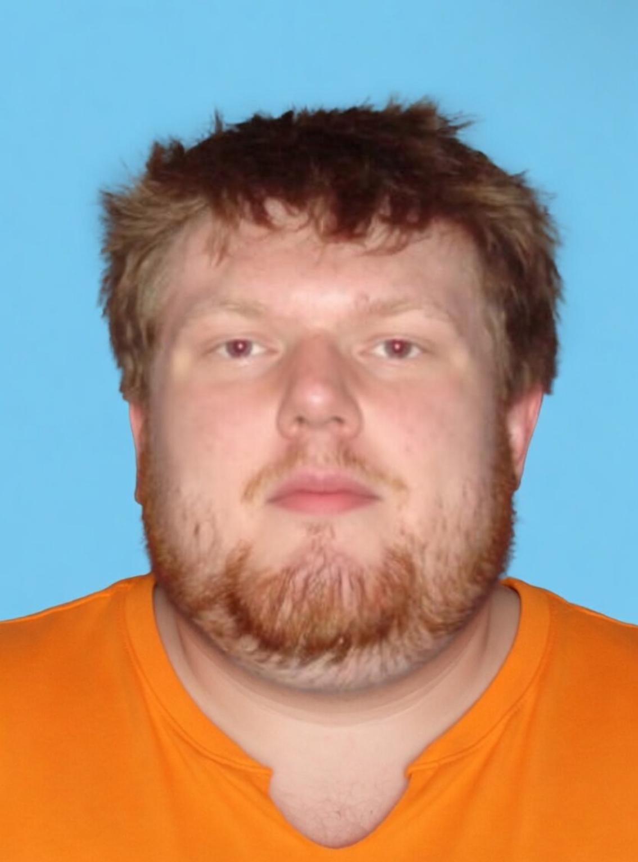

Robert Gurfenstan
1/31/90

ATTACHMENT A

DESCRIPTION OF ITEMS TO BE SEARCHED FOR

Evidence of a violation of 13 V.S.A. § 2301 (Second Degree Murder) which may be found stored within the cellular device belonging to Robert Gurfenstan (DOB: 01/31/90), currently in the custody of the Nocarn, V.T. Police Department. The device was voluntarily surrendered to law enforcement following the death of Dan Stone on April 13, 2026 and is being held at the Nocarn Police Department evidence facility pending the issuance of this warrant.

The data to be extracted from the PHONE includes:

- Location Data
- Instagram Posts/Comments/Direct Messages
- Search History

Retention of Forensic Images and Extractions

The government will retain a forensic image or extraction of each electronic storage device subjected to analysis for a number of reasons, including proving the authenticity of evidence to be used at trial, responding to questions regarding the corruption of data, establishing the chain of custody of data; refuting claims of fabricating, tampering, or destroying data; and addressing potential exculpatory evidence claims where, for example, a defendant claims that the government avoided it obligations by destroying data or returning it to a third party.

ATTACHMENT B:

IMAGES OF INSTAGRAM COMMENTS/DIRECT MESSAGES

Figure 1
The Post in which Rob and Dan began their confrontation

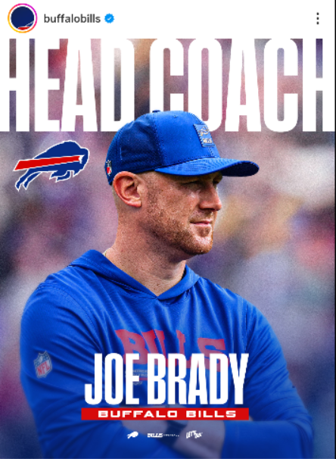

Figure 2
First Contact between Robert and Dan through the posts comment section
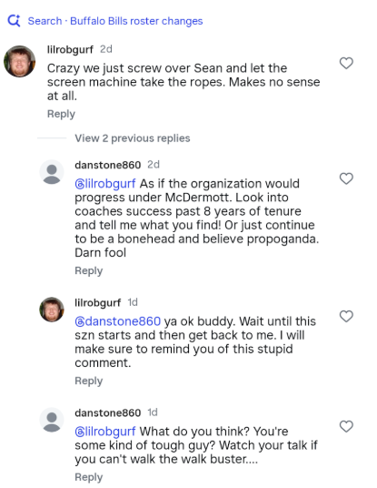

Figure 3
First Contact between Robert and Dan through Instagram Direct Messages
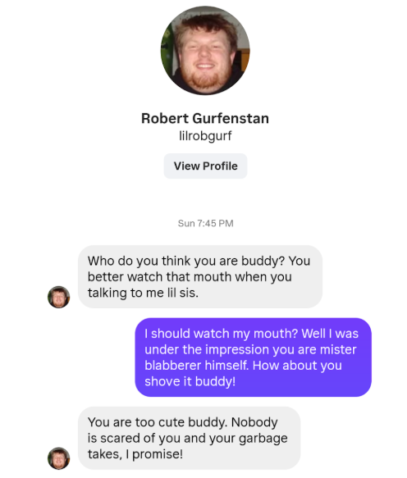

Figure 4
The scheduled meet up between the two at Dicks Sporting Goods (location of murder)
